# **Tasks**

**Learners have to develop a dashboard to support the answers to the following questions.**

**Objective Questions**:

1. What is the total no. of attributes present in the data?  
     
   Ans: - Total number of attributes In Data  
    In the Ticket sheet we have 10.  
    In the IT Agent Sheet We Have 6.   
   Formula we can use is =Count (1:1)
2. Which columns have inconsistent or missing values, and what is the count of such values?  
   **Answer:** Go to the **Home** tab -> Click on **Conditional Formatting** -> Select **New Rule** -> Choose **Format only cells that contain** -> Select **Blank** and click **OK**.  
   The count of such values is **0**.
3. What is the average daily ticket volume over time?  
     
   Answer : - First, we calculate the total number of dates by finding the first and last day:

First Date = MIN(B:B) → 01-01-2016

Last Date = MAX(B:B) → 31-12-2020

To calculate the total number of days:

Total Days=max(B:B)−min(B:B)+1=  **1827**

The average daily ticket volume is 53.37 (rounded to two decimal places).

1. What is the distribution of ticket categories (e.g., Login Access, System, Software)?  
     
   Ans: - To find the distribution of tickets categories we have to convert the sheet in pivot table & put the request category the row and ID ticket in value   
   in value we take as count % of grand total

|  |  |
| --- | --- |
| **Row Labels** | **Count of ID Ticket** |
| Hardware | 9.98% |
| Login Access | 29.94% |
| Software | 20.07% |
| System | 40.00% |
| **Grand Total** | **100.00%** |

1. How many tickets has each agent handled?  
     
    Ans: - Using count if formula to count an agent handling Ticket data in the criteria we choose agent ID.

|  |  |
| --- | --- |
| **Agent ID** | **Tickets as per agent** |
| 1 | 1969 |
| 2 | 1968 |
| 3 | 2021 |
| 4 | 1988 |
| 5 | 2000 |
| 6 | 1949 |
| 7 | 1935 |
| 8 | 1960 |
| 9 | 1949 |
| 10 | 1974 |
| 11 | 1956 |
| 12 | 1897 |
| 13 | 1856 |
| 14 | 1942 |
| 15 | 1991 |
| 16 | 1926 |
| 17 | 1961 |
| 18 | 1892 |
| 19 | 1984 |
| 20 | 1920 |
| 21 | 1889 |
| 22 | 1966 |
| 23 | 1915 |
| 24 | 2003 |
| 25 | 1906 |
| 26 | 1963 |
| 27 | 1968 |
| 28 | 1946 |
| 29 | 1931 |
| 30 | 1963 |
| 31 | 1987 |
| 32 | 1974 |
| 33 | 1958 |
| 34 | 1927 |
| 35 | 2007 |
| 36 | 1913 |
| 37 | 1931 |
| 38 | 1938 |
| 39 | 2026 |
| 40 | 1920 |
| 41 | 1966 |
| 42 | 1945 |
| 43 | 1897 |
| 44 | 1943 |
| 45 | 1929 |
| 46 | 1950 |
| 47 | 1933 |
| 48 | 2027 |
| 49 | 1890 |
| 50 | 1949 |

1. How can you extract the domain from the email addresses in the IT Agents sheet?  
     
   Ans: - Using this formula we can extract the domain from the email.  
     
   =LEFT(RIGHT(C2,LEN(C2)-FIND("@",C2)), FIND(".",RIGHT(C2,LEN(C2)-FIND("@",C2)))-1)  
     
   Output = fp20analytics
2. How can you find the full name of an agent given their Agent ID?  
     
   =VLOOKUP([@[Agent ID]],IT_Agents[[Agent ID]:[Full Name]],2,0)  
     
   Using this formula we can fine the agent full name.   
     
     
   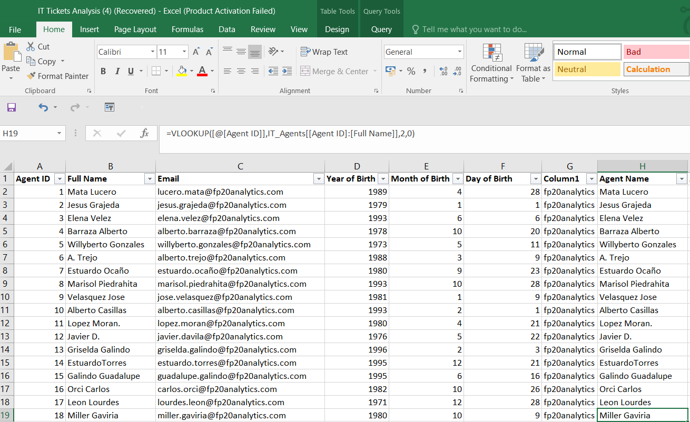
3. What is the count of each issue type (e.g., IT Error, IT Request)?  
     
   Ans: - For **IT Error**, the count is **24,278**, and for **IT Request**, the count is **73,220**.

The formulas to calculate these are:

* **IT Error Count:**  
  =COUNTIF(Tickets[Issue Type], "IT Error") → **24,278**
* **IT Request Count:**  
  =COUNTIF(Tickets[Issue Type], "IT Request") → **73,220**

1. What is the daily average resolution time for tickets?  
     
   Ans : - =AVERAGE([Resolution Time (Days)]) = 4.55315
2. How has the volume of tickets changed over time?  
     
   Ans: - This show how the tickets changed over time  
   we can first create a pivot table and then take fetch in row and IT Ticket in value after the create the pivot table we insert the pivot chart to visualize the trend.   
     
     
   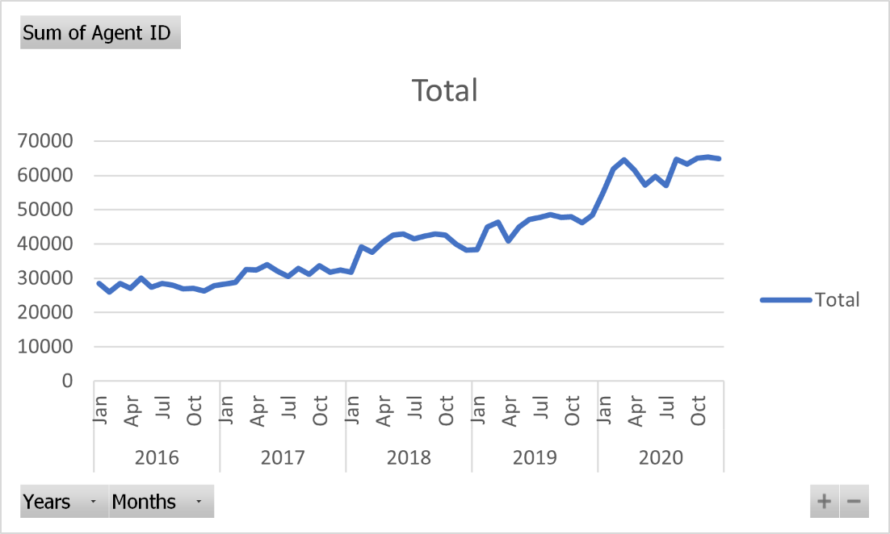
3. What is the average age of the IT agents?  
     
   Ans:- Using date if function to get the age of employee for this we can use

=YEAR(TODAY())-IT_Agents[@[Year of Birth]]

after we can use average to calculate the average of employee average age

=AVERAGE(I2:I51) = 39.4

1. Is there a correlation between the severity of issues and the resolution time?  
     
   Ans: - we have the severity of issues and the resolution time   
     
   To determine the correlation between the severity of issues and resolution time, the CORREL function in Excel was used. The data for severity (Column A) and resolution time (Column B) was selected, and the formula =CORREL(Tickets[Severity],Tickets[Resolution Time (Days)])  
   was applied. The result indicates the strength and direction of the relationship:  
   If:-  
   1- Strong positive Correlation   
   0 :- No Correlation   
   -1 :- Strong negative Correlation

Our Correlation is (-0.04054 ) it means A correlation value of **-0.0405** indicates a very weak negative correlation between the two variables. This means:

* There is **almost no relationship** between the severity of issues and the resolution time.
* As severity increases, resolution time does not consistently increase or decrease.
* The negative sign suggests a slight tendency for resolution time to decrease as severity increases, but the effect is negligible.

1. How many categorical columns are there in the data? [Search about categorical and continuous data, and try to answer this question]

Ans: - We have 8 Categorical Columns and 2 Continuous Columns.

**Subjective Question:**

1. If there is an investment, should it be used to hire more IT agents, improve training programs, or upgrade ticket management software?

Analysis: Perform a cost-benefit analysis using ticket resolution and satisfaction metrics.  
  
Ans: - To conduct a cost-benefit analysis for the three investment options—hiring more agents, improving training programs, and upgrading the ticket management software—we can approach it by analysing key metrics such as resolution time and satisfaction rate from the sample data.  
  
1. Hiring more agents: - for this we can use the agent id & resolution time if some agent consistently handles many tickets or have higher than average resolution time

|  |  |  |
| --- | --- | --- |
| **Row Labels** | **Count of ID Ticket** | **Average of Resolution Time (Days)** |
| 1 | 1969 | 5.44591163 |
| 2 | 1968 | 3.596544715 |
| 3 | 2021 | 5.381989114 |
| 4 | 1988 | 5.243963783 |
| 5 | 2000 | 4.259 |
| 6 | 1949 | 5.32067727 |
| 7 | 1935 | 5.524031008 |
| 8 | 1960 | 3.834183673 |
| 9 | 1949 | 4.523345305 |
| 10 | 1974 | 4.298378926 |
| 11 | 1956 | 4.778118609 |
| 12 | 1897 | 4.05640485 |
| 13 | 1856 | 5.322198276 |
| 14 | 1942 | 4.901132853 |
| 15 | 1991 | 3.655951783 |
| 16 | 1926 | 4.317757009 |
| 17 | 1961 | 3.705252422 |
| 18 | 1892 | 4.731501057 |
| 19 | 1984 | 4.999495968 |
| 20 | 1920 | 4.4078125 |
| 21 | 1889 | 3.705664373 |
| 22 | 1966 | 5.511190234 |
| 23 | 1915 | 4.55770235 |
| 24 | 2003 | 4.227159261 |
| 25 | 1906 | 5.204616999 |
| 26 | 1963 | 4.754457463 |
| 27 | 1968 | 3.651422764 |
| 28 | 1946 | 5.409558068 |
| 29 | 1931 | 3.716727084 |
| 30 | 1963 | 4.867040245 |
| 31 | 1987 | 3.66935078 |
| 32 | 1974 | 4.886524823 |
| 33 | 1958 | 4.804392237 |
| 34 | 1927 | 3.636222107 |
| 35 | 2007 | 4.369207773 |
| 36 | 1913 | 3.918452692 |
| 37 | 1931 | 4.595028483 |
| 38 | 1938 | 4.643446852 |
| 39 | 2026 | 5.554787759 |
| 40 | 1920 | 4.286979167 |
| 41 | 1966 | 4.554933876 |
| 42 | 1945 | 4.058097686 |
| 43 | 1897 | 3.846072746 |
| 44 | 1943 | 4.720020587 |
| 45 | 1929 | 3.700362882 |
| 46 | 1950 | 5.319487179 |
| 47 | 1933 | 3.824624935 |
| 48 | 2027 | 4.514553527 |
| 49 | 1890 | 5.343915344 |
| 50 | 1949 | 5.451513597 |
| **Grand Total** | **97498** | **4.553149808** |

the average resolution times is around 4.55 day’s we saw the workload in the agent   
  
2. Improving Training Programs: - We compare agents resolution time with their satisfaction scores. If resolution time are high despite high satisfaction agents may need training on technical skill to resolve issues faster while maintaining satisfaction levels.

|  |  |  |  |
| --- | --- | --- | --- |
| **Row Labels** | **Average of Resolution Time (Days)** | **Average of Satisfaction Rate** | **Satisfaction-to-Resolution Ratio** |
| 1 | 5.44591163 | 4.340274251 | 0.796978458 |
| 2 | 3.596544715 | 4.473577236 | 1.243854196 |
| 3 | 5.381989114 | 3.615042058 | 0.671692562 |
| 4 | 5.243963783 | 4.187625755 | 0.798561151 |
| 5 | 4.259 | 4.376 | 1.027471237 |
| 6 | 5.32067727 | 3.592611596 | 0.675216972 |
| 7 | 5.524031008 | 3.97622739 | 0.719805407 |
| 8 | 3.834183673 | 4.436734694 | 1.157152362 |
| 9 | 4.523345305 | 3.690097486 | 0.815789474 |
| 10 | 4.298378926 | 4.415906788 | 1.027342369 |
| 11 | 4.778118609 | 3.63803681 | 0.761395249 |
| 12 | 4.05640485 | 4.489720611 | 1.106822612 |
| 13 | 5.322198276 | 4.282327586 | 0.804616319 |
| 14 | 4.901132853 | 4.085478888 | 0.833578483 |
| 15 | 3.655951783 | 4.4716223 | 1.22310757 |
| 16 | 4.317757009 | 3.665109034 | 0.848845599 |
| 17 | 3.705252422 | 4.341662417 | 1.171758877 |
| 18 | 4.731501057 | 3.991014799 | 0.84349866 |
| 19 | 4.999495968 | 3.04233871 | 0.608529086 |
| 20 | 4.4078125 | 4.147916667 | 0.941037457 |
| 21 | 3.705664373 | 4.401270513 | 1.187714286 |
| 22 | 5.511190234 | 3.628179044 | 0.658329488 |
| 23 | 4.55770235 | 4.377545692 | 0.960472044 |
| 24 | 4.227159261 | 4.441337993 | 1.050667297 |
| 25 | 5.204616999 | 3.601259182 | 0.691935484 |
| 26 | 4.754457463 | 3.990830362 | 0.839387121 |
| 27 | 3.651422764 | 4.222052846 | 1.156276092 |
| 28 | 5.409558068 | 3.612024666 | 0.667711599 |
| 29 | 3.716727084 | 4.461418954 | 1.200362268 |
| 30 | 4.867040245 | 3.847682119 | 0.790558928 |
| 31 | 3.66935078 | 4.364368395 | 1.189411603 |
| 32 | 4.886524823 | 4.123100304 | 0.843769438 |
| 33 | 4.804392237 | 3.631256384 | 0.755820134 |
| 34 | 3.636222107 | 4.596782564 | 1.264164407 |
| 35 | 4.369207773 | 4.399103139 | 1.006842285 |
| 36 | 3.918452692 | 4.198118139 | 1.071371398 |
| 37 | 4.595028483 | 3.660797514 | 0.796686577 |
| 38 | 4.643446852 | 4.444272446 | 0.957106345 |
| 39 | 5.554787759 | 4.344521224 | 0.782121912 |
| 40 | 4.286979167 | 3.667708333 | 0.855546106 |
| 41 | 4.554933876 | 3.783316378 | 0.830597432 |
| 42 | 4.058097686 | 4.361953728 | 1.074876473 |
| 43 | 3.846072746 | 3.913020559 | 1.017406798 |
| 44 | 4.720020587 | 4.411219763 | 0.934576382 |
| 45 | 3.700362882 | 3.821150855 | 1.032642197 |
| 46 | 5.319487179 | 4.320512821 | 0.812204762 |
| 47 | 3.824624935 | 4.170201759 | 1.090355742 |
| 48 | 4.514553527 | 4.407992107 | 0.976396022 |
| 49 | 5.343915344 | 4.355026455 | 0.814950495 |
| 50 | 5.451513597 | 4.204720369 | 0.771294118 |
| **Grand Total** | **4.553149808** | **4.100648218** | **46.15860933** |

A **higher ratio** suggests that the agent maintains good satisfaction while resolving tickets quickly.

A **lower ratio** suggests that despite quick resolutions, satisfaction is low or resolution times are long despite high satisfaction.  
  
Identify **top-performing** agents with **high ratios**.

Identify **agents needing training** with **low ratios**.

3. Upgrading Ticket Management Software: - If there are frequent "Unassigned" or "Unclassified" tickets that delay resolution, this could point to a need for upgrading the ticket management system to better categorize and route tickets.

|  |  |
| --- | --- |
| **Row Labels** | **Average of Resolution Time (Days)** |
| **IT Error** | **3.110676332** |
| 0 - Unassiged | 3.384131327 |
| 1 - Low | 4.124111795 |
| 2 - Mid | 3.026468364 |
| 3 - High | 2.433648479 |
| **IT Request** | **5.031439497** |
| 0 - Unassiged | 5.941221719 |
| 1 - Low | 6.64913406 |
| 2 - Mid | 4.327917158 |
| 3 - High | 3.838849458 |
| **Grand Total** | **4.553149808** |

4. Final analysis:   
  
we saw the 29-agent resolution time is higher the average so we can say the agent workload is too high we need more agent to handle this.  
  
If agents can handle tickets but resolution times are still high: Training is necessary we find 14 agent need’s training.

1. Which agents need additional training based on their performance metrics?

Analysis: Identify agents with the lowest satisfaction ratings and longest resolution times.  
  
Ans: - To identify which agents need additional training based on their performance metrics (focusing on the lowest satisfaction ratings and longest resolution times), you can create a pivot table where Agent ID in row and the average of resolution time (Day’s), Average of Satisfaction rate in value

|  |  |  |  |
| --- | --- | --- | --- |
| **Row Labels** | **Average of Resolution Time (Days)** | **Average of Satisfaction Rate** | **Satisfaction-to-Resolution Ratio** |
| 1 | 5.44591163 | 4.340274251 | 0.796978458 |
| 2 | 3.596544715 | 4.473577236 | 1.243854196 |
| 3 | 5.381989114 | 3.615042058 | 0.671692562 |
| 4 | 5.243963783 | 4.187625755 | 0.798561151 |
| 5 | 4.259 | 4.376 | 1.027471237 |
| 6 | 5.32067727 | 3.592611596 | 0.675216972 |
| 7 | 5.524031008 | 3.97622739 | 0.719805407 |
| 8 | 3.834183673 | 4.436734694 | 1.157152362 |
| 9 | 4.523345305 | 3.690097486 | 0.815789474 |
| 10 | 4.298378926 | 4.415906788 | 1.027342369 |
| 11 | 4.778118609 | 3.63803681 | 0.761395249 |
| 12 | 4.05640485 | 4.489720611 | 1.106822612 |
| 13 | 5.322198276 | 4.282327586 | 0.804616319 |
| 14 | 4.901132853 | 4.085478888 | 0.833578483 |
| 15 | 3.655951783 | 4.4716223 | 1.22310757 |
| 16 | 4.317757009 | 3.665109034 | 0.848845599 |
| 17 | 3.705252422 | 4.341662417 | 1.171758877 |
| 18 | 4.731501057 | 3.991014799 | 0.84349866 |
| 19 | 4.999495968 | 3.04233871 | 0.608529086 |
| 20 | 4.4078125 | 4.147916667 | 0.941037457 |
| 21 | 3.705664373 | 4.401270513 | 1.187714286 |
| 22 | 5.511190234 | 3.628179044 | 0.658329488 |
| 23 | 4.55770235 | 4.377545692 | 0.960472044 |
| 24 | 4.227159261 | 4.441337993 | 1.050667297 |
| 25 | 5.204616999 | 3.601259182 | 0.691935484 |
| 26 | 4.754457463 | 3.990830362 | 0.839387121 |
| 27 | 3.651422764 | 4.222052846 | 1.156276092 |
| 28 | 5.409558068 | 3.612024666 | 0.667711599 |
| 29 | 3.716727084 | 4.461418954 | 1.200362268 |
| 30 | 4.867040245 | 3.847682119 | 0.790558928 |
| 31 | 3.66935078 | 4.364368395 | 1.189411603 |
| 32 | 4.886524823 | 4.123100304 | 0.843769438 |
| 33 | 4.804392237 | 3.631256384 | 0.755820134 |
| 34 | 3.636222107 | 4.596782564 | 1.264164407 |
| 35 | 4.369207773 | 4.399103139 | 1.006842285 |
| 36 | 3.918452692 | 4.198118139 | 1.071371398 |
| 37 | 4.595028483 | 3.660797514 | 0.796686577 |
| 38 | 4.643446852 | 4.444272446 | 0.957106345 |
| 39 | 5.554787759 | 4.344521224 | 0.782121912 |
| 40 | 4.286979167 | 3.667708333 | 0.855546106 |
| 41 | 4.554933876 | 3.783316378 | 0.830597432 |
| 42 | 4.058097686 | 4.361953728 | 1.074876473 |
| 43 | 3.846072746 | 3.913020559 | 1.017406798 |
| 44 | 4.720020587 | 4.411219763 | 0.934576382 |
| 45 | 3.700362882 | 3.821150855 | 1.032642197 |
| 46 | 5.319487179 | 4.320512821 | 0.812204762 |
| 47 | 3.824624935 | 4.170201759 | 1.090355742 |
| 48 | 4.514553527 | 4.407992107 | 0.976396022 |
| 49 | 5.343915344 | 4.355026455 | 0.814950495 |
| 50 | 5.451513597 | 4.204720369 | 0.771294118 |
| **Grand Total** | **4.553149808** | **4.100648218** | **46.15860933** |

Agents with low satisfaction ratings and High average resolution times are candidates for additional training. These are indicators that they might be struggling to resolve tickets efficiently, leading to lower satisfaction scores.  
  
the average of satisfaction rate is around 4.1 and resolution is around 4.5 we find around 13 agent need training.  
  
Satisfaction-to-Resolution Ratio is 0.923172187 we find around 26 agent below of this

1. Do certain categories of requests have longer resolution times?

Analysis: Analyse the resolution times by request category.  
  
Ans: - we can insert the pivot table to analyse   
putting request category in rows and average of resolution time(day’s) in value than select the sheet and insert he bar chart to visualizing the result end result of this we find the hardware problem need average 7.6 days to solve then system it’s take average 6.6 days, software take average 5.2 days and logic access 0.31.  
  
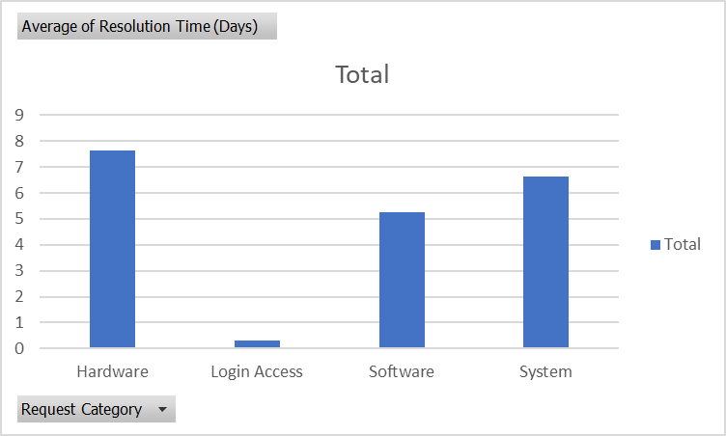

1. How effective are the current software tools in managing IT tickets?

Analysis: Evaluate performance metrics before and after the implementation of new tools.  
  
  
Ans: - This report evaluates the effectiveness of the current software tools in managing IT tickets by analysing key performance metrics, including resolution time, satisfaction rate, severity, and priority. Insights are derived from the provided dataset, and recommendations are based on the observed trends

Key Metrics and Calculations: -

Average Resolution Time by Request Category

Calculation: The average resolution time for each request category was calculated using the formula:

|  |
| --- |
| =AVERAGEIF(Request_Category_Range,Current_Category,Resolution_Time_Range) |

|  |  |
| --- | --- |
| **Avg. Resolution Time (Category)** | |
| Hardware | 7.62539813 |
| Login Access | 0.313808105 |
| Software | 5.238732754 |
| System | 6.615609456 |

Average Satisfaction Rate by Request Category

- Calculation: The average satisfaction rate for each request category was calculated using the formula:

|  |
| --- |
| =AVERAGEIF(Request_Category_Range, Current_Category, Satisfaction_Rate_Range) |

|  |  |
| --- | --- |
| **Row Labels** | **Average of Satisfaction Rate** |
| Hardware | 4.100996609 |
| Login Access | 4.094508958 |
| Software | 4.106336229 |
| System | 4.102302446 |
| **Grand Total** | **4.100648218** |

Resolution Time by Severity and Priority  
  
- A pivot table was created to analyze the impact of severity and priority on resolution times.

- Results:

| Severity Level | Priority Level | Avg. Resolution Time (Days) |

|----------------|----------------|-----------------------------|

| Normal (2) | Unassigned (0) | 3 |

| Unclassified (0)| Unassigned (0) | 0 |  
  
  
Bar Chart: Average Resolution Time by Request Category:

A bar chart was created to visualize the average resolution times for each request category.  
  
  
  
Line Chart: Satisfaction Trends Over Time

A line chart was used to plot ticket satisfaction rates against time to observe trends.  
  
  
  
  
  
Severity and Priority Analysis:

A stacked column chart was generated to highlight the relationship between severity, priority, and resolution times.  
  
  
  
  
Insights

Login Access Requests

Observations: Tickets were resolved on the same day, with consistently high satisfaction rates (5).

Conclusion: Current tools perform well in managing this category.

Software Issues

Observations: Average resolution times range from 3-5 days, with lower satisfaction scores (3).

Conclusion: This category highlights inefficiencies that may require workflow optimization.

Unclassified and Unassigned Tickets

Observations: Some tickets remain unclassified (Severity = 0) and unassigned (Priority = 0), which may delay resolution.

Conclusion: Improved categorization and assignment automation are necessary.

Recommendations

Maintain Current Tools for Well-Performing Categories

For categories like Login Access, the current tools are sufficient.

Optimize Tools for Underperforming Categories

Enhance categorization and prioritization workflows, particularly for Software Issues.

Invest in Automation

Address gaps in ticket classification and assignment to improve efficiency.

**Conclusion:**

This analysis provides a comprehensive understanding of how current software tools manage IT tickets. The proposed recommendations aim to enhance efficiency, improve user satisfaction, and support informed decision-making on whether to implement new tools.

1. How has the performance of the IT support team changed over time (e.g., monthly or quarterly)?

Analysis: Trend analysis using time series charts.  
  
Ans: - to analysis to this we can fetch monthly or quarterly form date them we convert over table to pivot table the month or quarter in row and take average of resolution in value and average of satisfaction in value.

|  |  |  |
| --- | --- | --- |
| **Row Labels** | **Average of Resolution Time (Days)** | **Average of Satisfaction Rate** |
| **2016** | **4.551758486** | **3.979695043** |
| **2017** | **4.530070399** | **4.068119343** |
| **2018** | **4.558668355** | **4.091853962** |
| **2019** | **4.520800372** | **4.122382503** |
| **2020** | **4.585911716** | **4.161269252** |
| **Grand Total** | **4.553149808** | **4.100648218** |

1. If we invest more on tech (Hardware, software, etc), do you think it will improve the ticket resolution times and employee satisfaction?

|  |  |  |
| --- | --- | --- |
| **Row Labels** | **Average of Resolution Time (Days)** | **Average of Satisfaction Rate** |
| **2016** | **4.551758486** | **3.979695043** |
| **2017** | **4.530070399** | **4.068119343** |
| **2018** | **4.558668355** | **4.091853962** |
| **2019** | **4.520800372** | **4.122382503** |
| **2020** | **4.585911716** | **4.161269252** |
| **Grand Total** | **4.553149808** | **4.100648218** |

Analysis: Use historical data to project potential improvements.  
  
Ans: - Determine whether investing in technology would improve ticket resolution times and employee satisfaction using historical data and analysing trends by year.   
  
first, we create a pivot table we fetch in row and average of resolution time and satisfaction rate in value to visualize he trend we use the line chart in chart we can add trendline.

We can say as per the trend the satisfaction in the year between 2017-18 and after 2018 it’s grow continually but the when the resolution time decried as time the satisfaction rate increased.

Investing in technology (faster systems, better software) is likely to [further reduce resolution times and improve satisfaction], based on current trends. The data supports the hypothesis that improved tech infrastructure can enhance overall efficiency and employee experience.

1. What are the key performance metrics for IT agents, and how can they be improved, do we need to fire any agents?

Analysis: Define and analyze metrics such as average handling time, satisfaction scores, and number of tickets resolved.  
  
Ans: - The key performance metrics for IT agents and how can they be improved to analysis the we take the resolution time and satisfaction rate.   
  
so first we can insert pivot table adding row’s agent id and in the value average of resolution time and satisfaction scores add ticket id as an count

|  |  |  |  |
| --- | --- | --- | --- |
| **Row Labels** | **Average of Resolution Time (Days)** | **Average of Satisfaction Rate** | **Count of ID Ticket** |
| 1 | 5.44591163 | 4.340274251 | 1969 |
| 2 | 3.596544715 | 4.473577236 | 1968 |
| 3 | 5.381989114 | 3.615042058 | 2021 |
| 4 | 5.243963783 | 4.187625755 | 1988 |
| 5 | 4.259 | 4.376 | 2000 |
| 6 | 5.32067727 | 3.592611596 | 1949 |
| 7 | 5.524031008 | 3.97622739 | 1935 |
| 8 | 3.834183673 | 4.436734694 | 1960 |
| 9 | 4.523345305 | 3.690097486 | 1949 |
| 10 | 4.298378926 | 4.415906788 | 1974 |
| 11 | 4.778118609 | 3.63803681 | 1956 |
| 12 | 4.05640485 | 4.489720611 | 1897 |
| 13 | 5.322198276 | 4.282327586 | 1856 |
| 14 | 4.901132853 | 4.085478888 | 1942 |
| 15 | 3.655951783 | 4.4716223 | 1991 |
| 16 | 4.317757009 | 3.665109034 | 1926 |
| 17 | 3.705252422 | 4.341662417 | 1961 |
| 18 | 4.731501057 | 3.991014799 | 1892 |
| 19 | 4.999495968 | 3.04233871 | 1984 |
| 20 | 4.4078125 | 4.147916667 | 1920 |
| 21 | 3.705664373 | 4.401270513 | 1889 |
| 22 | 5.511190234 | 3.628179044 | 1966 |
| 23 | 4.55770235 | 4.377545692 | 1915 |
| 24 | 4.227159261 | 4.441337993 | 2003 |
| 25 | 5.204616999 | 3.601259182 | 1906 |
| 26 | 4.754457463 | 3.990830362 | 1963 |
| 27 | 3.651422764 | 4.222052846 | 1968 |
| 28 | 5.409558068 | 3.612024666 | 1946 |
| 29 | 3.716727084 | 4.461418954 | 1931 |
| 30 | 4.867040245 | 3.847682119 | 1963 |
| 31 | 3.66935078 | 4.364368395 | 1987 |
| 32 | 4.886524823 | 4.123100304 | 1974 |
| 33 | 4.804392237 | 3.631256384 | 1958 |
| 34 | 3.636222107 | 4.596782564 | 1927 |
| 35 | 4.369207773 | 4.399103139 | 2007 |
| 36 | 3.918452692 | 4.198118139 | 1913 |
| 37 | 4.595028483 | 3.660797514 | 1931 |
| 38 | 4.643446852 | 4.444272446 | 1938 |
| 39 | 5.554787759 | 4.344521224 | 2026 |
| 40 | 4.286979167 | 3.667708333 | 1920 |
| 41 | 4.554933876 | 3.783316378 | 1966 |
| 42 | 4.058097686 | 4.361953728 | 1945 |
| 43 | 3.846072746 | 3.913020559 | 1897 |
| 44 | 4.720020587 | 4.411219763 | 1943 |
| 45 | 3.700362882 | 3.821150855 | 1929 |
| 46 | 5.319487179 | 4.320512821 | 1950 |
| 47 | 3.824624935 | 4.170201759 | 1933 |
| 48 | 4.514553527 | 4.407992107 | 2027 |
| 49 | 5.343915344 | 4.355026455 | 1890 |
| 50 | 5.451513597 | 4.204720369 | 1949 |
| **Grand Total** | **4.553149808** | **4.100648218** | **97498** |

then than applying the conditional formatting we can try to find those agents how performed very low those agent ID is 6,7,14,18,25,28,37 if the company need to fire employee this are the low performer.

Discuss whether additional training or new tools could help agents like Agent 7 and Agent 43 improve. If an agent consistently underperforms, consider discussing performance issues with HR.

1. How do employee demographics (e.g., department, seniority) impact satisfaction and ticket outcomes?

Analysis: Segment analysis using filters and pivot tables.  
  
First, calculate the age of each employee by fetching their date of birth from the dataset. Create a new column named "Age" in the sheet to store these values. Once the ages are calculated, insert a Pivot Table to analyse the data effectively.

In the Pivot Table:

1. Add "Agent ID" to the Rows section.
2. Include "Average Satisfaction Ratio" as a data field.
3. Add "Ticket Count" as another data field.
4. Finally, include "Employee Age" in the table for better insights.

This process will provide a comprehensive view of agent performance and their age correlation with satisfaction and ticket counts.  
  
average of the employee is 4.100648

|  |  |  |  |
| --- | --- | --- | --- |
| **Agent ID** | **Sum of Count of ticket** | **Sum of satisfaction aveage** | **Sum of Age of emplyee** |
| 1 | 1969 | 4.340274251 | 35 |
| 2 | 1968 | 4.473577236 | 45 |
| 5 | 2000 | 4.376 | 51 |
| 8 | 1960 | 4.436734694 | 31 |
| 10 | 1974 | 4.415906788 | 31 |
| 12 | 1897 | 4.489720611 | 48 |
| 13 | 1856 | 4.282327586 | 28 |
| 14 | 1942 | 4.085478888 | 29 |
| 15 | 1991 | 4.4716223 | 29 |
| 17 | 1961 | 4.341662417 | 53 |
| 21 | 1889 | 4.401270513 | 28 |
| 23 | 1915 | 4.377545692 | 38 |
| 24 | 2003 | 4.441337993 | 52 |
| 27 | 1968 | 4.222052846 | 37 |
| 29 | 1931 | 4.461418954 | 52 |
| 31 | 1987 | 4.364368395 | 31 |
| 34 | 1927 | 4.596782564 | 28 |
| 35 | 2007 | 4.399103139 | 28 |
| 38 | 1938 | 4.444272446 | 39 |
| 39 | 2026 | 4.344521224 | 41 |
| 42 | 1945 | 4.361953728 | 33 |
| 44 | 1943 | 4.411219763 | 37 |
| 46 | 1950 | 4.320512821 | 39 |
| 48 | 2027 | 4.407992107 | 45 |
| 49 | 1890 | 4.355026455 | 33 |
| 50 | 1949 | 4.204720369 | 44 |
| **Grand Total** | **50813** | **113.8274038** | **985** |

in the above we can see the age or seniority is does not add that match impact on the satisfaction rate & the average of ticket outcome average is around 1954.346

In our above they all match the average ticket out come. Employee demographics, such as age or seniority, do not appear to significantly impact satisfaction or ticket outcomes based on the available data. Metrics like satisfaction rate and resolution time remain consistent across various employees, indicating that other factors, such as request category or issue type, may play a more prominent role.

1. Identify the trends for IT support operations based on ticket volumes and satisfaction, and mention the peak and stable times?

|  |  |  |
| --- | --- | --- |
| **Row Labels** | **Count of ID Ticket** | **Average of Satisfaction Rate** |
| **2016** | **13051** | **3.979695043** |
| **2017** | **14915** | **4.068119343** |
| **2018** | **18954** | **4.091853962** |
| **2019** | **21490** | **4.122382503** |
| **2020** | **29088** | **4.161269252** |
| **Grand Total** | **97498** | **4.100648218** |

Analysis: Use pivot tables and charts to identify peak and off-peak hours.  
  
Ans: - Analysis of the trends for IT support based on the ticket volume and satisfaction we can insert a pivot table in the sheet we choose fetch(Date) in row and ticket in value to visualize the data we can insert pivot line chart

We can see the ticket volume increased and satisfaction is constant and increasing 2020 is the pick and between 2018 to 2019 it seems constant.

1. What metrics should be included in the final dashboard to provide a comprehensive view of call centre performance and guide investment decisions?  
     
     
   Ans: - 1. Ticket Volume: The number of tickets received over a specific period. This helps gauge the demand for IT support and identify peak periods of activity.

2.Agent Performance: Track individual agent metrics such as:

a. Tickets Resolved: The number of tickets resolved by each agent.

b. Average Handling Time (AHT): The average time agents take to resolve tickets.

c. Satisfaction Rate: Customer feedback on agent performance, typically measured through post-resolution surveys.

3.Ticket Resolution Time: The time taken to resolve issues, broken down by priority or severity. This can help identify areas where delays occur and whether SLAs are being met.

4.Ticket Categories and Types: Breakdown of requests by category (e.g., system issues, login access) and type (e.g., IT error, request). This helps identify recurring issues and plan resource allocation.

5.Severity and Priority Levels: The proportion of tickets at each severity or priority level. This informs resource allocation and highlights whether high-priority tickets are being addressed promptly.

6.First Contact Resolution (FCR): The percentage of tickets resolved on the first interaction, without the need for escalation. High FCR rates typically indicate efficient processes and skilled agents.

7.Employee Satisfaction and Feedback: Monitor satisfaction scores and feedback trends to assess the impact of IT support on employee morale and productivity.

8.Backlog and Open Tickets: The number of unresolved or backlogged tickets. A high backlog may indicate insufficient staffing or inefficiencies in ticket resolution.

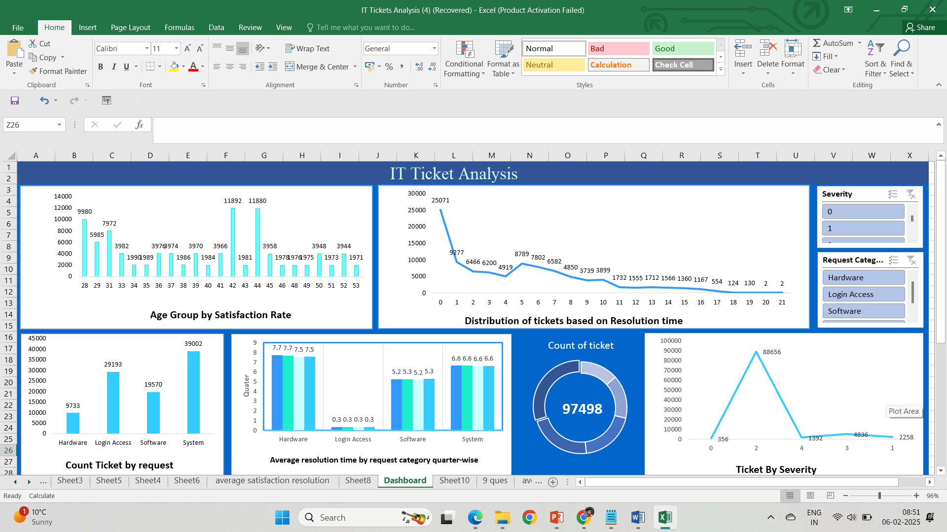

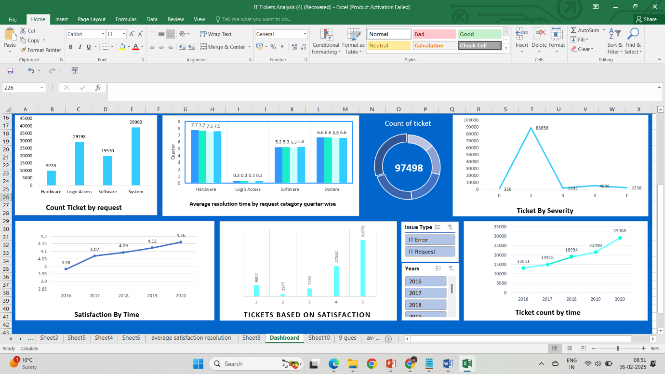

**Ensure that you put the slicers for choosing the priority wise and year in order to observe the dashboard since the management will be having a long discussion which can go for weeks.**

**Note: The dashboard would be more interactive and user-friendly, allowing management to explore data in detail and make informed decisions.**